Unit Test Cases:

1. Get api key



1. Enter city name to get weather details and create api url

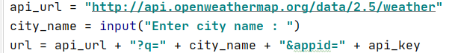

1. Get request to api_url and returns json data

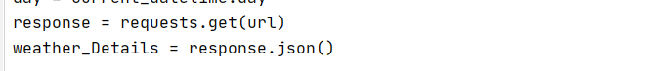

1. Get current date and check current date is prime or not

If date is prime

Return json

Else

Date is not prime so no date